REPORT
- CONECTED SPRING BOOT BACKEND USING RETROFIT
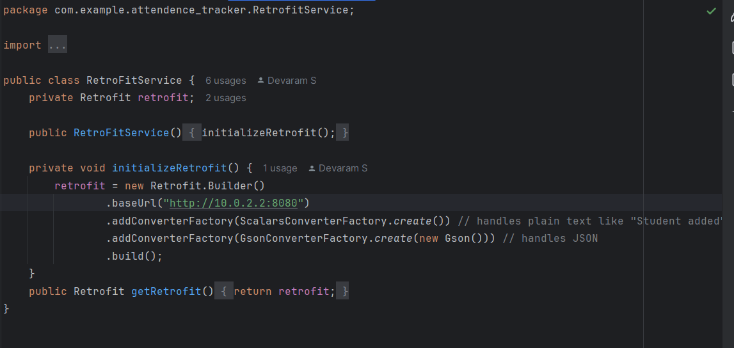
- DATABASE STRUCTURE
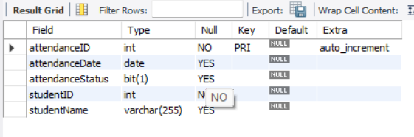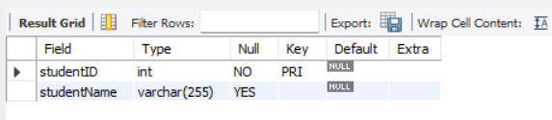

- BASIC RETRIEVAL FROM BACKEND AND SAVING TO BACKEND
